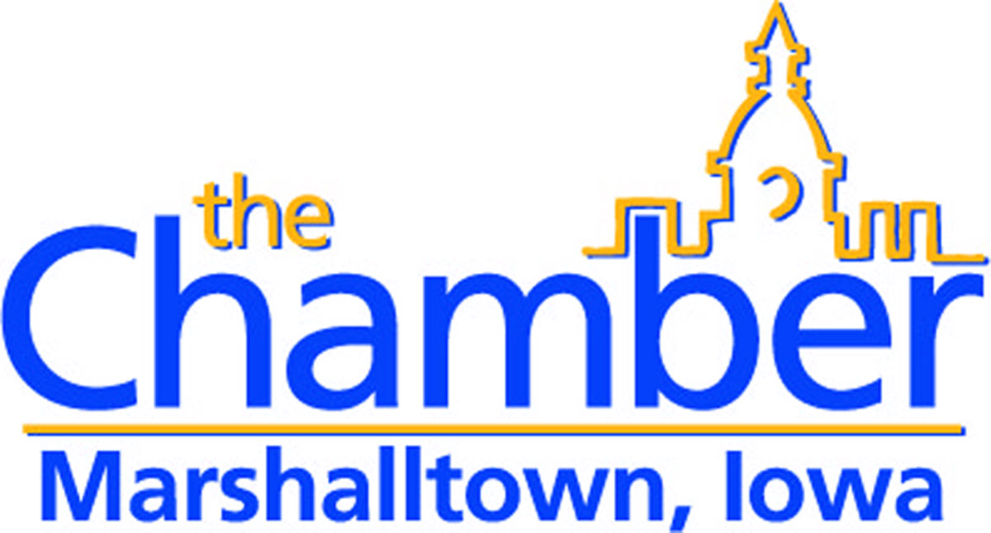

It’s time to update your online business directory listing!

Business name:

Business Website:

Business categories/ headings: (please list up to 4):

Searchable key words: (please list up to 50)

-See reverse-

Please note any changes in physical or mailing address, phone number or email address.

Text (up to 150 words);

Please email any new graphics or logos to lolberding@marshalltown.org. You are allowed TWO graphics.

Please return this form to PO Box 1000 – Marshalltown, IA 50158 or email information to lolberding@marshalltown.org.

